**Video Staff detection**

|  |  |
| --- | --- |
| Environment/Packages | Version |
| Windows | 11 |
| python | 3.8 |
| jupyter notebook | 6.5.2 |
| openCV | 4.5.2 |
| numpy | 1.23.4 |
| modelscope | 1.9.4 |

Introduction:

Using pretrained model in modelscope doing head detection. Drawing the rect of predict result.

Example: We can see that there is some false detection in this example, model predict dustbin as a human head.

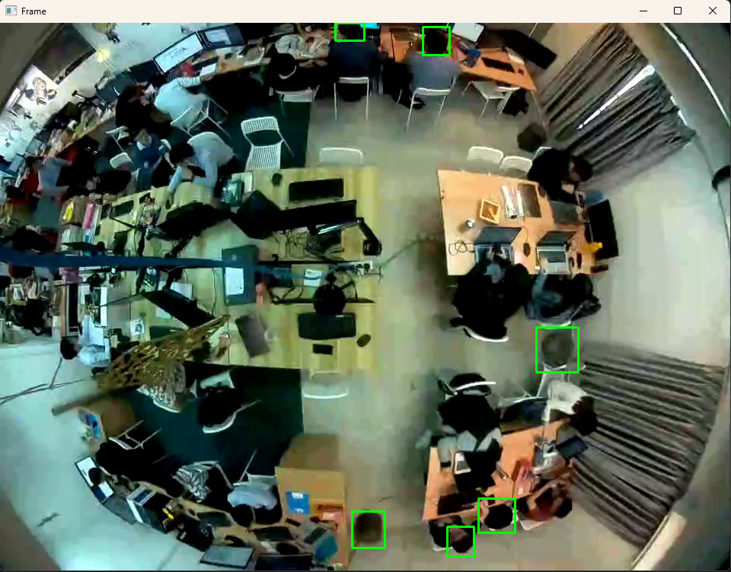

Nametag Detection:

Assume name tag at the bottom left of human head. Using edge detection method (sobel), and findContours method to calculate the number of contours.

relative_nametag_pos = [0, 10, 30, 20] #relative x0, y0, width, heigtht

Using naïve classification:

if # cnts sobelx + # cnts in sobely == 4 and # cnts sobelxy == 1:

nametag = True

else:

nametag = False

Result:

Drawback:

* False classification happened
* Nametag must be in a certain angle
* Nametag detection depends on human head detection
* Nametag position depends on human head position

Way to Improve:

Frame data is top-down wide angle image, model detects this kind of data is not so accurately. Using transfer learning retrain again model with frame data will be better in human head detection.

Using small CNN detects nametag. (YOLO, Resnet, …etc)

Find out the intrinsic matrix and distortion matrix of CCTV to calibrate the curve frame to flat.

Tried Method:

Using motionDetection way to detect human. It will not work when staff is not moving.

Using warpPerspective method try to warp frame to 2D frame, but head detection is worst.

Reference:

[Motion Detection](https://pysource.com/2021/01/28/object-tracking-with-opencv-and-python/)

[Object Tracking](https://www.youtube.com/watch?v=EV-dmxfP-l4&t=1s)

[Head Detection Model](https://modelscope.cn/models/damo/cv_tinynas_head-detection_damoyolo/summary)